***Muhammad Abdullah Kazmi***

***BSCS-6B***

***188990***

***LAB#06***

***ADVANCED PROGRAMMING***

***TASK#01:***

**Calculator.java:**

**package** com.org.kazmi.lab06;

**public** **class** Calculator {

**public** **int** add(**int** i, **int** j)

{

**return** i + j;

}

**public** **int** sub(**int** i, **int** j)

{

**if**(i > j)

{

**return** i - j;

}

**else**

**return** j - i;

}

}

**Test_Calculator.java:**

**package** com.org.kazmi.lab06;

**import** **static** org.junit.Assert.*;

**import** org.junit.Test;

**public** **class** Test_Calculator {

Calculator c = **new** Calculator();

@Test

**public** **void** test() {

*assertEquals*(5,c.add(3, 2));

// fail("Not yet implemented");

}

}

**POM.xml:**

<project xmlns=*"http://maven.apache.org/POM/4.0.0"* xmlns:xsi=*"http://www.w3.org/2001/XMLSchema-instance"*

xsi:schemaLocation=*"http://maven.apache.org/POM/4.0.0 http://maven.apache.org/xsd/maven-4.0.0.xsd"*>

<modelVersion>4.0.0</modelVersion>

<groupId>com.org.kazmi</groupId>

<artifactId>lab06</artifactId>

<version>0.0.1-SNAPSHOT</version>

<packaging>jar</packaging>

<name>lab06</name>

<url>http://maven.apache.org</url>

<properties>

<project.build.sourceEncoding>UTF-8</project.build.sourceEncoding>

</properties>

<dependencies>

<dependency>

<groupId>junit</groupId>

<artifactId>junit</artifactId>

<version>3.8.1</version>

<scope>test</scope>

</dependency>

</dependencies>

</project>

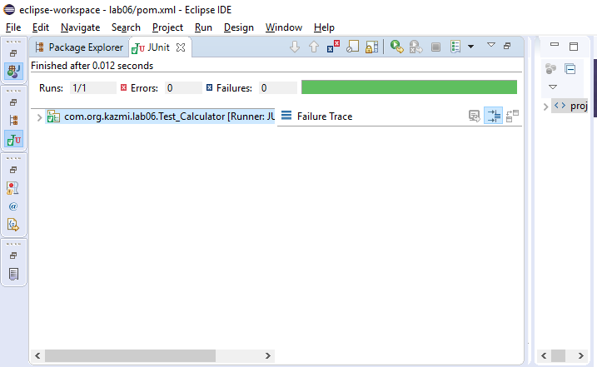

***TASK#02:***

**testEncryptionStrategy:**

**package** com.org.kazmi.lab06_task2;

**import** **static** org.junit.Assert.*assertEquals*;

**import** org.junit.Test;

**public** **class** testEncryptionStrategy {

EncryptionStrategy aesStrategy=**new** AesEncryptionStrategy();

Encryptor aesEncryptor=**new** Encryptor(aesStrategy);

@Test

**public** **void** test() {

aesEncryptor.setPlainText("This is plain text");

*assertEquals*(1,aesEncryptor.encrypt());

// fail("Not yet implemented");

}

}

